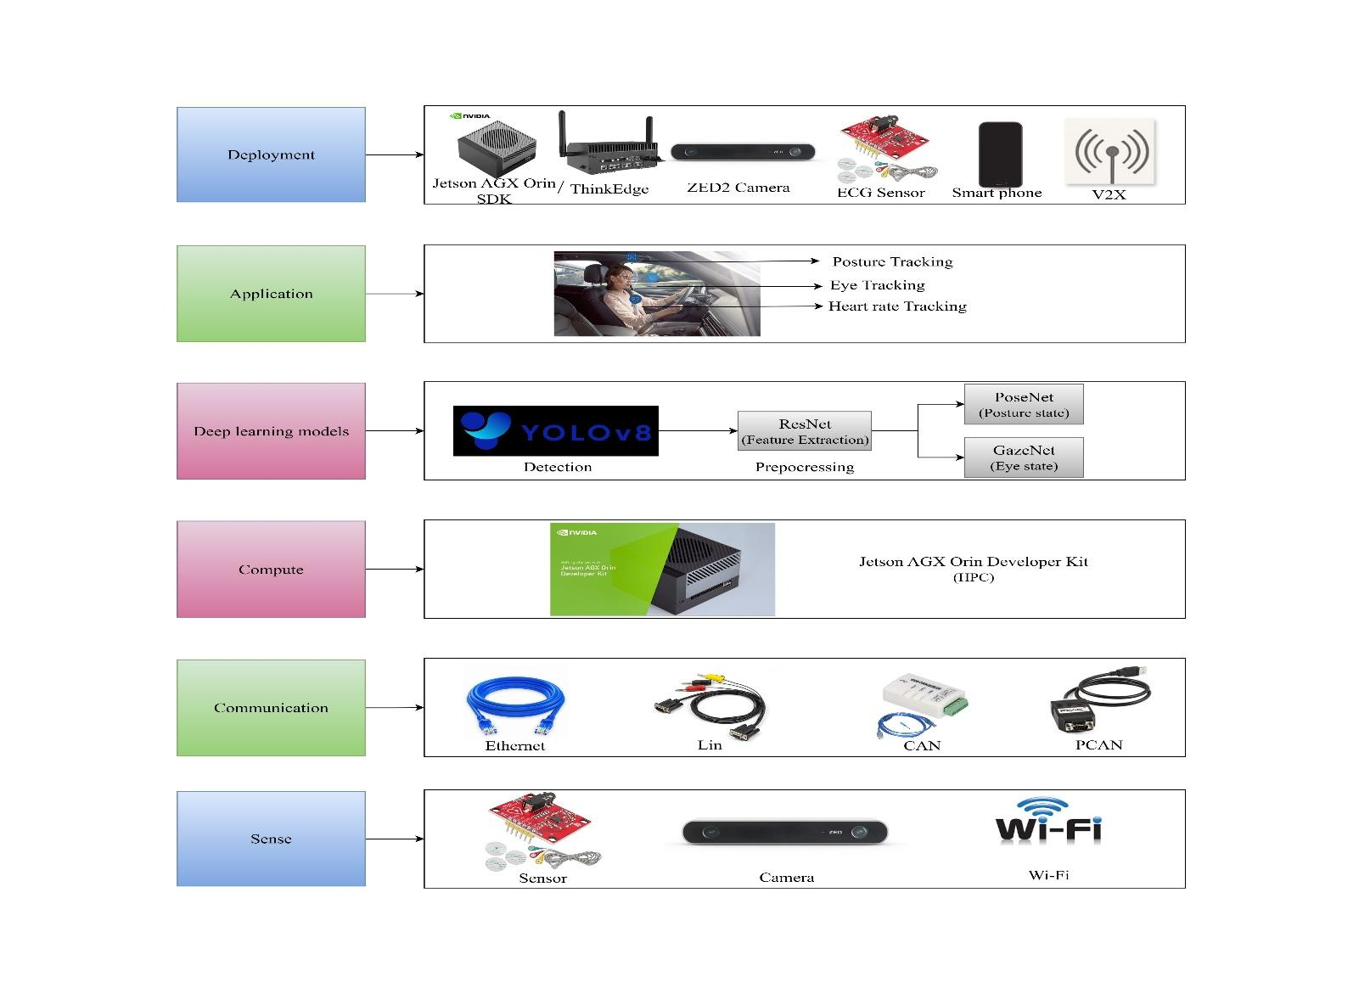
LAYER ARCHITECTURE DIAGRAM
Figure 1: Layered design approach
This layered architecture represents a systematic approach for passenger health monitoring in a semi-autonomous vehicle. At the base, the sense layer collects raw data using ECG sensors for heart rate, ZED2 cameras for posture and eye tracking, and Wi-Fi for connectivity. The communication layer ensures reliable data transfer through Ethernet, LIN, CAN, and PCAN protocols. The compute layer, powered by the Jetson AGX Orin developer kit, performs high-performance processing of incoming data. On top of this, the deep learning models layer applies YOLOv8 for detection, ResNet for feature extraction, and specialized networks like PoseNet and GazeNet for posture and eye-state analysis. These insights feed into the application layer, which enables posture, eye, and heart-rate tracking to monitor passenger health and alertness in real time. Finally, the deployment layer integrates all components including edge computing devices, sensors, smartphones, and V2X communication into the semi-autonomous vehicle, ensuring real-world functionality and seamless monitoring of passenger well-being.

